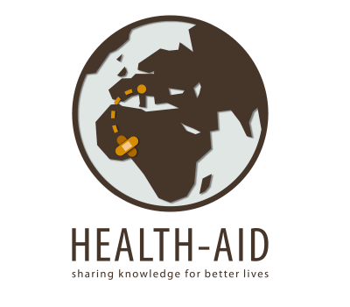
HEALTH-AID ONLUS
Italian-Ghanaian Project
for the Rural-deprived in Saboba District

www.health-aid.org
E-mail: healthaidonlus@gmail.com

APPLICATION FORM

Surname……………………………….First Name…………………………..

Date and place of birth……………………………………………Age……...

Passport # …………………Sex………Nationality………………………….

Address………………………………..Zip Code…………………………….

Town/City……………………………..Country……………………………..

Phone……………………. E-mail…………….………………...................

Occupation.....….……………………………………………………………..

Health Professional Yes No Other........................................................

English language BASIC INTERMEDIATE FLUENT

Particular Skills…………………………………………………………………………

Period: 1st choice from…………………..……to………………………….
2nd choice from………………………..to………………………….
3rd choice from………………………..to………………………….

I would like to partecipate as Health Worker Logistician
Educational Worker Supporter
Visitor

REMARKS…………………………………………………………………..

Please fill in the AF and send it with A.YOUR PHOTO
To: B. MOTIVATION LETTER

Dr. DIEGO MANZONI
Via Roma, 5
I-24060 BAGNATICA (BG) Italy
Tel. +39 338 2905699
E-mail: healthaidonlus@gmail.com

